

Supervision
A Graduated Approach to Staff Wellbeing

Approved by Governing Body On
To be Reviewed On
Signed on Behalf of the Governing Body | 

Intention of Graduated Approach to Staff Wellbeing
- Provide system to promote Staff Voice
- Support staff in the demands of their role in school.
- Provide a solution based approach to aspects of the role that may be causing concern, uncertainty or frustration.
- Provide support with anything that is affecting Staff Wellbeing or Mental Health. (Inside and outside of school)
- Signpost staff to available support agencies and professionals.
Graduated Approach Offer to Staff Wellbeing in practice
- Weekly Check-ins
- ½ Termly Supervision sessions
- Coaching/consultations with MHST/ Park’s Mental Health First Aider/ SLT
- Exceed’s Health & Wellbeing Employee Assistance Programme (Health Assured)

- Weekly Check-ins

Intention – discuss/bring attention to: any concerns including children, logistics, support etc
Weekly Check-ins are scheduled to take place at the following times:

  - Learning Behaviour Assistants (hosted by Pastoral and Behaviour Managers) -
    - Tuesdays - 8.20am-8.40am

  - Pastoral & Behaviour Team (hosted by Assistant Headteacher for Inclusion)
    - Thursdays – 8.00am- 8.25am

  - Behaviour Team (hosted by Deputy Headteacher)
    - Thursdays – 8.00am- 8.25am

  - Teachers Team (hosted by Senior Leadership Team/Phase Leaders)
    - Wednesdays – 8.20am-8.40am

  - Phase Leaders (hosted by Senior Leadership Team)
    - Tuesdays - 7.45am-8.15am

  - Safeguarding (hosted by Headteacher/Assistant Headteacher for Safeguarding)
    - Fridays – 9.00am- 10.00am

  - SEND (hosted by Assistant Headteacher for Inclusion)
    - Tuesdays – 9.00-12.00

  - Senior Leadership Team (hosted by Headteacher)
    - Wednesdays – 3.00pm – 5.00pm

  - Administration Team (Hosted by Business Manager)
    - Mondays – 3.00 pm – 4.00pm

  - Site Team (Hosted by Business Manager)
    - Mondays – 2.00 pm – 3.00pm

- ½ Termly Supervision sessions

  - All Staff Teams (as of Weekly Check-ins)
    - 3rd Tuesday each ½ Term - 2.45pm-3.45pm
    - Supervision discussion/sessions based on themes raised in Check-in sessions or a current difficulty.
    - Please see below An Introduction to Supervision.

- Coaching/consultations with MHST/ Park’s Mental Health First Aider/ SLT
  - Involves a ‘mutual inquiry process’ that creates a shared sense of responsibility for figuring out what is wrong and how to fix it.
  - Staff self-refer to Mental Health Support Team/Park’s Mental Health First Aiders/Senior Leadership Team/Educational Psychologist should they want individual support around resolving issues that are impacting on them – this may be in school or out of school issues that are impacting on wellbeing
    - Mental Health Support Team - Drop in session each Wednesday from 2.45pm
    - Educational Psychologist – Drop in sessions during visits
    - Park’s Mental Health First Aiders can be consulted at any time for support
    - Senior Leadership Team can be consulted at any time for support

- Exceed’s Health & Wellbeing Employee Assistance Programme (Health Assured)
  - The Trust wide Employee Assistance Programme (EAP) is a free confidential service which can be accessed by all employees. EAP aims to support employees who maybe experiencing difficulties for a variety of reasons.
  - EAP offers employees access to support including:
    - Telephone Counselling
    - Financial Information
    - Legal Information
    - Consumer Issues
    - Relationship Advice
    - Employment advice
  - This is only a selection of the services provided. To find out more information and to gain access to the Health & Well-being Portal, please visit:
    - www.healthassuredeap.com
    - Username: please see school staff room notice boards
    - Password: please see school staff room notice boards

Introduction to Supervision
What is Supervision?
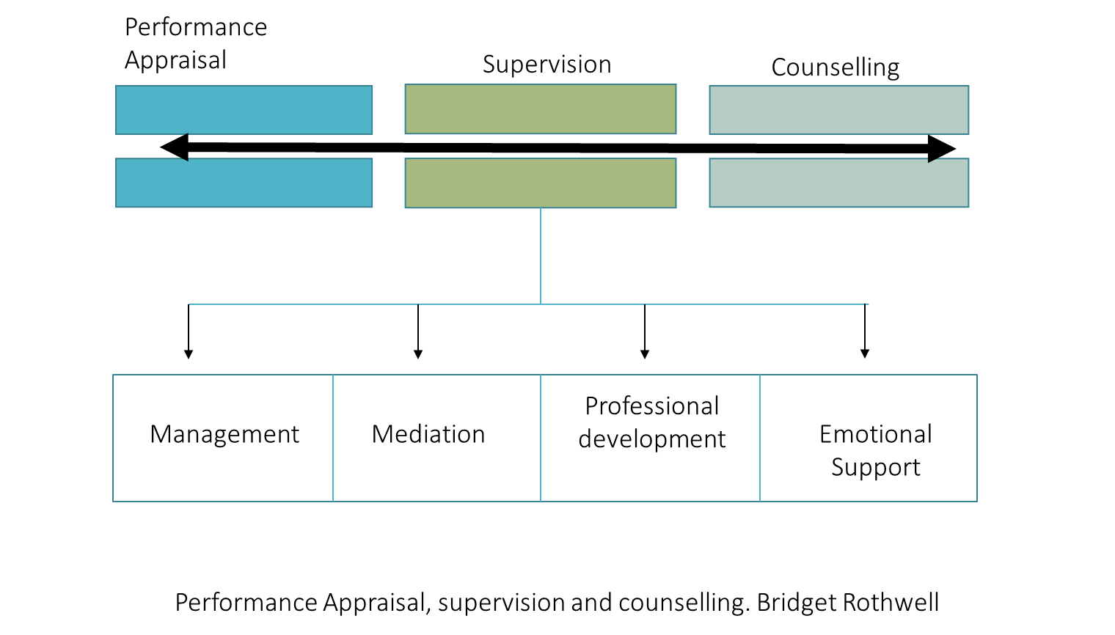
Understanding the four functions of supervision helps to clarify what supervision is and what it is not. It also makes clear the boundary between supervision and performance appraisal at one end of the spectrum, and supervision and counselling at the other. Line Managers (Hosts) need to remain mindful that they need to offer emotional support and not just managerial input. Their role is equally to ensure accountability and not only to support and encourage.
In short, supervision is about finding the balance between these two areas; not being a full counsellor but not being a full manager: although they might stray into either at times - it is about finding the middle ground.

Intention – discuss in depth any themes that have arisen during Weekly Check-in sessions
Supervision is NOT – managerial, blaming or one-sided
Supervision IS – structured, problem solving, solution based, supportive, ‘good enough’
Supervision employs empathy, congruence, openness and genuineness.

Supervision - it's about checking in, not checking up

What does Group Supervision look like?
- Scheduled and booked in the school diary
- In organise groups
- Begins with a reminder of boundaries, confidentiality and respect
- Supervision uses a Solution-focused model and framework based on six stages, which are:
  - Case Presentation
  - Clarification
  - Theories
  - Strategies
  - Dialogue
  - Next Steps
- The Supervision process
  - During Check-in sessions the topic of Supervision discussion is agreed and the following roles assigned:
    - Facilitator - Line Manager will guide the session
    - Case Presenter – shares the ‘problem’ with the group
    - Consultants – others within the group
- The six stages of Supervision
  - Case Presentation
    - The Case Presenter has 5-7 minutes to outline case, ensuring important information is presented
    - Presenter has uninterrupted time to describe the situation. It helps if they can state what benefit is hoped for as a result of the discussion as well as the problem/ tricky situation.
  - Clarification
    - Participants ask questions to clarify their own understanding of the issue (avoid giving advice disguised as a question e.g. “Have you tried...”) ‘What?’ ‘When?’ ‘Where?’ ‘Who?’ and ‘How?’ questions are encouraged as they provide descriptions of what has already taken place. Example questions:
    - Is there a time when this is better? Is there a time this doesn’t happen?
    - What are the young person’s views?
    - How often does this happen?
    - What have you tried so far and how successful was it? Why do you think x didn’t work?
    - What ‘question’ do you want to be answered?
  - Theories
    - Participants offer ideas about what might be contributing to the situation in a sensitive way.
    - What might be going on for the young person?
  - Strategies
    - Participants offer helpful input. This can be a reflection, a powerful question, a shared experience, suggestions of ways forward/next steps/things to explore.
    - Each team member offers only one reflection at a time and the problem presents listens (and does not comment at this time).
  - Dialogue
    - Presenter follows up on some of the theories and strategies offered. Which ones make the most sense to the situation? What strategies/ideas have they heard that they think could be particularly helpful?
  - Next Steps
    - Concrete next steps are identified.
    - What is the first step that could be taken towards this (24-48 hours)?
    - Line manager progresses next steps

